Arkansas State University Museum Scout Patch:

PORTALS OF THE SOUL

Ancient Peoples of Northeast Arkansas

For Brownie Girl Scouts and Cub Scouts
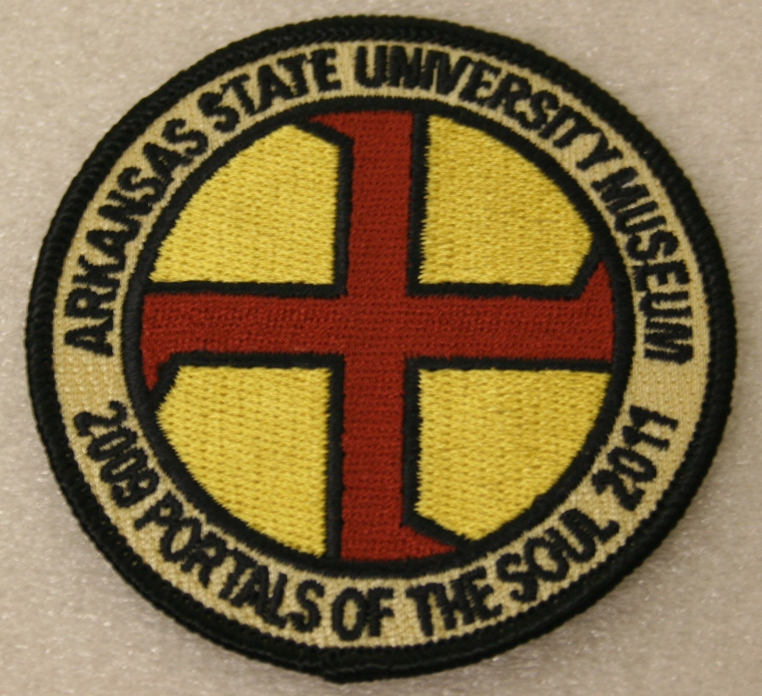 | This patch is designed to help scouts learn about native peoples of Northeast Arkansas.  To earn the activity patch:  1. Complete the attached worksheet at the ASU Museum. Gallery hours: Tuesday 9 am–7 pm; Wednesday–Friday 9 am–5 pm; Saturday 9 am–5 pm; Sunday 1–5 pm.  2. Sign and make a comment in the Museum’s guest book.  3. Get the signature of a museum employee below.
To get the activity patch:
1. Take your signed, completed worksheet to:
ASU Museum Gift Shop attendant
2. Purchase the patch there at the ASU Gift Shop.
Good luck!
I certify that ____________________________________ has completed the activity sheet to receive the ASU Museum Portals activity patch. Signed:

Museum staff name Date
MASTERS OF THE MASTODON
1. What did Paleoindians wear for warmth?

2. What giant mammal did Paleoindians hunt?

ANCIENT FARMERS
3. Name one of the plants grown by ancient farmers.

4. Some Native American pottery looked like what vegetable?

ARTFUL INDUSTRIES

5. Name the two animal hides in the case.

6. Name one use of the Bow and Arrow.

EMBLEMS OF STATUS

7. Name some of the objects made from shell.

8. Name one item that was traded from far away.

POTTERY ENGINEERS

9. What was the main way of making pottery in prehistoric Arkansas?

10. Who were the “pottery engineers” in ancient Arkansas?
THE VANISHED ART

11. Name at least two examples of the “vanished art.”

12. Name some of the ways prehistoric people used woven goods.

CULINARY ART

13. What vegetable was the basis for nearly every meal in prehistoric times?

14. Why are some of the pots blackened or charred?

FEAST!

15. Who prepared the food for a feast?

16. What liquid was an important part of ritual drinking?

PORTALS

17. How many worlds made up the ancient universe or “cosmos?”

18. Find a portal symbol in this case and draw it here.

SYMBOLS OF THE SPIRIT WORLD

19. Find a swastika symbol and explain what it meant in the Mississippian spirit world.

20. What did swirls symbolize?

POWER ART

21. What is an example of “power art” today?

12. What do the horns on the horned vessels look like?

THE MISSISSIPPIAN COSMOS

23. What constellation of stars in the night sky was considered the “Path of Souls?”

24. In the Mississippian cosmos, birds lived in which world?

Below, draw or describe your favorite thing in the exhibition:

Arkansas State University Museum Scout Patch:

PORTALS OF THE SOUL

Ancient Peoples of Northeast Arkansas

For Junior–Ambassador Girl Scouts and Boy Scouts
This patch is designed to help scouts learn about native peoples of Northeast Arkansas.
To earn the activity patch:
1. Complete the attached worksheet at the ASU Museum. Gallery hours: Tuesday 9 am–7 pm; Wednesday–Friday 9 am–5 pm; Saturday 9 am–5 pm; Sunday 1–5 pm.
2. Sign and make a comment in the Museum’s guest book.
3. Get the signature of a museum employee below.
To get the activity patch:
1. Take your signed, completed worksheet to:
Girl Scout office at 4803 East Johnson Ave, in Jonesboro, Arkansas.
2. Purchase the patch there at the Girl Scout Office.
Good luck!
I certify that ____________________________________ has completed the activity sheet to receive the ASU Museum Portals activity patch. Signed:

Museum staff name Date

MASTERS OF THE MASTODON
1. What people lived in northeast Arkansas at the end of the last Ice Age?

2. Why did mastodons make regular or seasonal migrations?

ANCIENT FARMERS
3. Name the four independent centers of plant domestication in the world.

4. Name the “three sisters.”

ARTFUL INDUSTRIES

5. During what time period were Nodena Points used?

6. What kind of costumes did hunters wear to sneak up on their prey?

EMBLEMS OF STATUS

7. What was the social significance of necklaces, pendants, and gorgets?

8. What shell from the Gulf coast did people most prefer for personal adornment?

POTTERY ENGINEERS

9. Who were the ancient pottery engineers?

10. Before pottery, how did people cook their food?

THE VANISHED ART

11. How do we know people made baskets in prehistoric northeast Arkansas?

12. Name two types of prehistoric weaving tools.

CULINARY ART

13. Why are some of the pots blackened or charred?

14. What would you choose to eat from the Mississippian menu?

FEAST!

15. Why did prehistoric people have feasts?

16. Why do we have feasts today?

PORTALS

17. What was the purpose of portals in the Mississippian cosmos?

18. What did the Milky Way represent in ancient belief?

SYMBOLS OF THE SPIRIT WORLD

19. Find a swastika symbol and explain what it meant in the Mississippian spirit world.

20. What do the swirls symbolize?

POWER ART

21. What power did prehistoric people use to help ensure a successful hunt?

22. How does modern “power art” (such as food and designer brands) influence you?

THE MISSISSIPPIAN COSMOS

23. Find an effigy of the supernatural being who can travel to all three worlds.

24. Describe the “Above World” of the Mississippian Cosmos.

Below, draw or describe your favorite thing in the exhibition:

